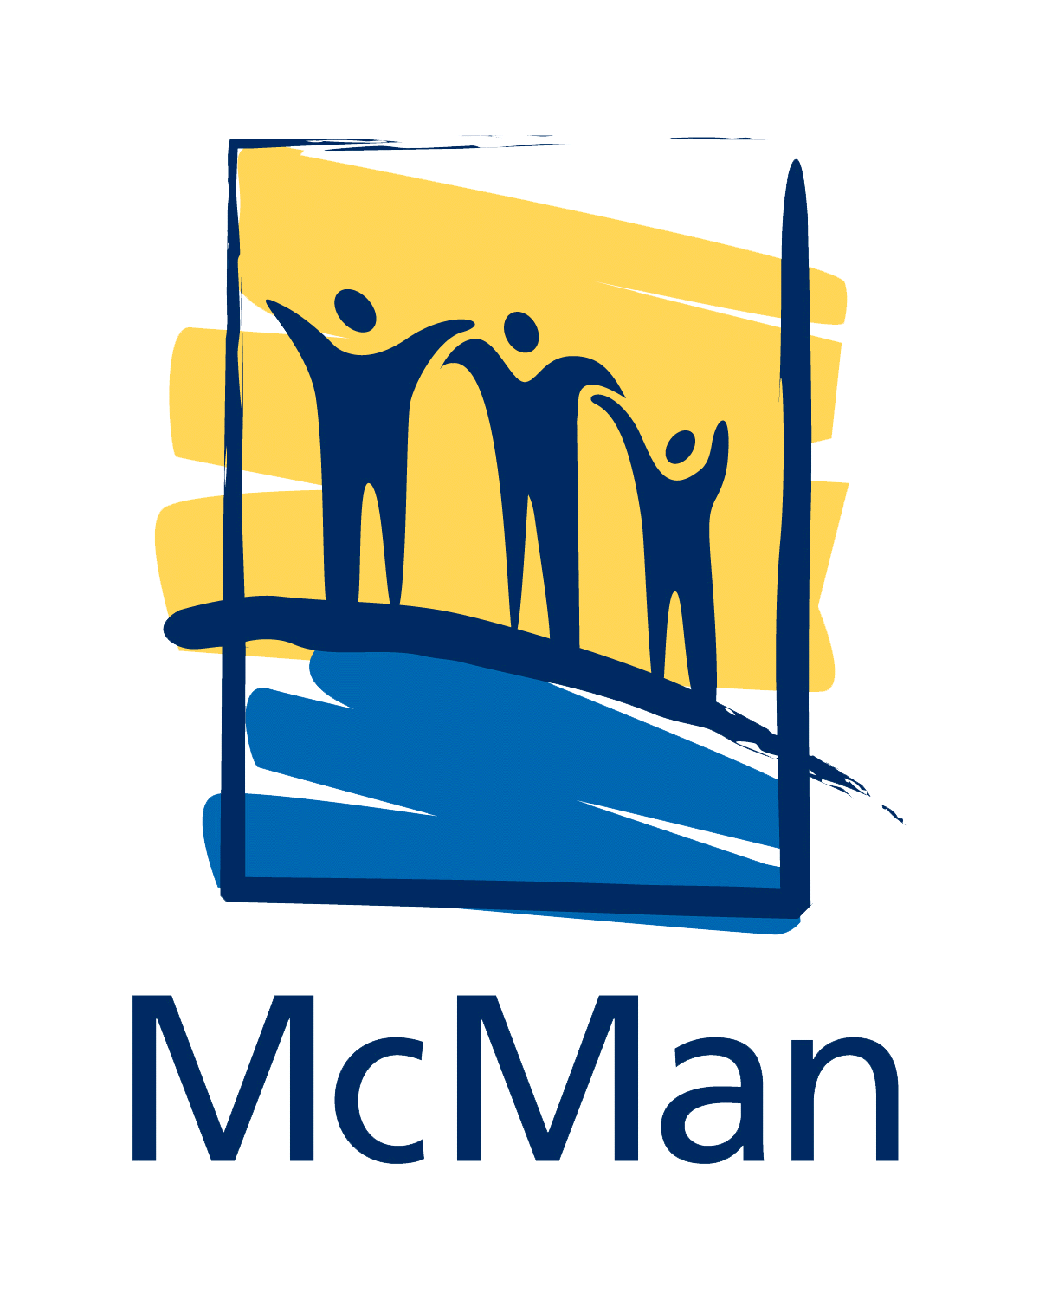
A Great Place for Great People to do Great Work!
Since 1975, McMan Youth, Family and Community Services Association has been providing responsive
and innovative social services through a comprehensive range of programs. As a well respected
not-for-profit social service agency, McMan has earned a solid reputation of doing great things.
If you want to work for a great place and do great work with great people, look no further.

McMan Child/Youth Homes -Edmonton, AB
Temporary Positions Until June 2026 and Permanent Positions

McMan Youth, Family and Community Services will continue to operate three additional Group Homes alongside our existing PCC homes until June 2026. To ensure we are fully staffed during this time, we are actively seeking to fill the following temporary and permanent roles.
These homes provide care to youth who struggle with complex pain-based behaviours, using the CARE Model alongside demonstrating a strength-based, solution-focused approach. Team members are central to mentoring, supporting, and guiding youth in developing the skills they need for independence and well-being.
Supervisor-GC-01
The Group Care supervisor will be assigned to a home and will be responsible for overseeing key operational and service delivery components. The Supervisor leads a collaborative team, ensuring CARE Model standards and supports day-to-day operations and interventions. The supervisor will work predominantly days however will be available to work varied schedule to accommodate being on-site for all shifts including days, evenings, weekends and overnights.
Schedule: 40 hours/week | Pay: $32.85–$36.98/hr
Senior Youth Worker-GC-02
The Senior Youth Worker is a position responsible for providing supervision, support and counseling to youth and their families in the program adhering to the CARE Model. Their responsibilities include case planning and management, the supervision of relief staff, counseling, facilitating recreation and leisure, and the care and safety of the youth. The senior youth worker will work on a varied schedule to accommodate being on-site for all shifts including days, evenings, weekends and overnights.
Schedule: 40 hours/week | Pay: $29.32–$32.96/hr
Youth Worker – Multiple Full-Time and Part-Time Positions
The Youth Worker provides supervision, support, and counseling to youth and their families following the CARE Model. This role also involves accompanying youth to Nation and supporting cultural connections as part of their care planning.
Schedule: 40 hours/week | Pay: $24.65–$27.74/hr
Full Time Youth Worker-Rotating Schedule GC-03
- Full-time (40 hours per week) Monday to Friday 1 week of 7-3, 1 week of 3-11
- Full-time (40 hours per week) Monday to Friday 1 week of 7-3 and then 2 weeks of 3-11
Overnight Awake Shift-GC-04
- Full-time (40 hours per week) Sunday to Thursday 11:00 pm to 7:00 am

Weekend Day Shift-GC-05
- Part-time (24 hours per week or Every Second Weekend) Friday and Saturday 11:00am to 11:00pm
Weekend Overnight Awake Shift-GC-06
- Part-time, (24 hours per week) Friday and Saturday 11:00pm to 11:00am
Relief Worker – Multiple Positions --GC-07
Relief Workers provide supervision, support, and counseling to youth and their families, working collaboratively with the team and support networks to help youth achieve their goals. They must be available for all shifts at both locations. Pay rate: $24.65 per hour Various shifts and Hours available
What you bring:
- Completion of a Degree/Diploma in Human Services
- Six (6) months of directly related experience in youth/family work
- Equivalencies may be considered
- Standard First Aid—Level C CPR + AED
- Police Information Check; including Vulnerable Persons Sector Check (from within the last 6 months)
- Children Services Intervention Record Check (from within the last 6 months)
- Valid Class 5 driver’s license and current drivers abstract are required, a reliable vehicle and auto insurance would be assets
- Strong communication and relationship building skills are an asset
- Ability to deal with complex high needs
- Experience with trauma and developmental delays
- Knowledge of de-escalation techniques and harm reduction practices
- CARE (Children and Residential Experiences) training is an asset
- Desire to see youth succeed

Closing Date: Open until Suitable Applicant is found
Competition Number: Each position has a number. Please quote the number in your resume

Please email your interest to: careers.edmnorth@mcman.ca

We value your continued interest and patience throughout this process. Interested staff members will be contacted directly regarding next steps.

