Alberta Provincial Advocacy

Toolkit for ALIGN Association of Community Services

Prepared for
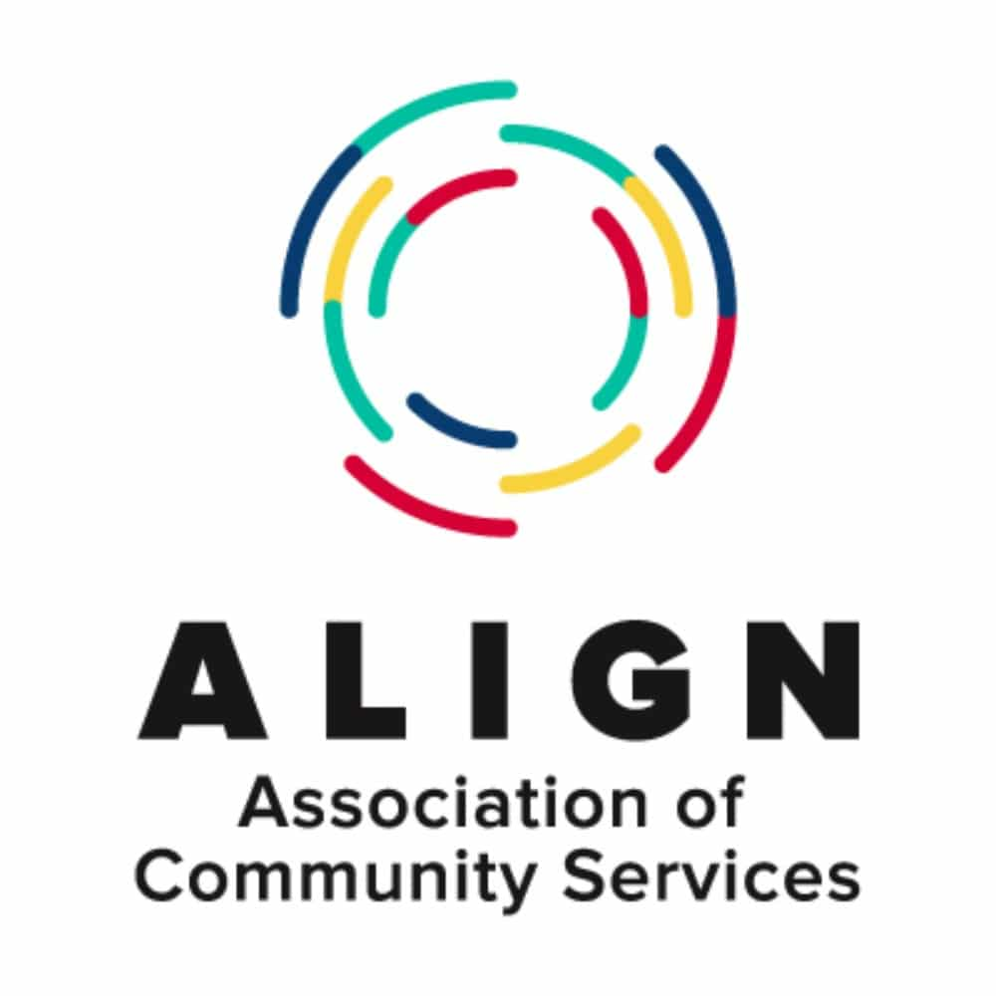

Table of Contents

Community Action Network 3
Getting to Work 4
Ways to Connect 4
In Person Meeting 5
Social Media 6
Events 6
Other 7
Talking Points 8
Key Messages 9
Sustainable Funding for Community Services 9
Keep Services in Communities 10
Decline in Quality of Care 11
Phrases To Use In Your Messaging 12
Scripts 13
Leave Behind 14
Glossary 15

Community Action Network

The objective of this guide will be to provide members of ALIGN with the knowledge and confidence to form a successful Community Action Network.
What is a Community Action Network (CAN)?
- A group of members, or members of the Board of Directors, who want to engage more with government to showcase their industry.
- Takes advantage of the members good standing in their communities across the province
- Builds on local relationships and provides a framework for developing and maintaining positive relationships with decision makers.
- Network members are given support that includes resources (i.e., templates, briefing notes, issue position papers, logistical government relations advice) to make interactions with elected officials easy and consistent.
Why is it important?
- The main benefit of the CAN is that it helps the association deliver a consistent message to the Government in a quick and credible way.
- Keeps issues important to ALIGN in the minds of targeted MLAs.
- ‘Feedback loop’ from GoA, MLAs are more likely to get ‘honest’ feedback from the minister, which they are more likely to share with a local constituent if they have a relationship with him/her.
How will it help?
- ALIGN is the voice of the many children and family community service providers across the province, but it is a broad voice and not as personal as a relationship between an MLA and his or her constituent.
- Messaging from the members in their home communities is far more impactful to government. If a minister gets 15 calls from MLAs across the province who are hearing consistent messages from trusted members of the community, this will have an impact.
- There is strength in numbers, the more perspectives a politician can be exposed to, the more informed they can be when they are creating legislation.

Getting to Work
There are several ways to engage with your elected official;
- Volunteer with your local constituency association. Constituency associations will typically accept any form of help you are willing to provide, or simply attend a constituency association event or fundraiser. You can find these opportunities on the party website or the MLA’s social media.
- Request an in-person meeting at your constituency office in your community.
- Make a phone call, you may be able to speak to someone on the constituency office team and raise your issues with them and they can pass it along to the MLA. You should also ask for the MLA to return your call so you can speak to them directly.
- Invite your elected officials to an event or tour. Local sectors are very important to elected officials.
- Through social media there are many platforms that the MLA, and parties use. Pick the one you feel most comfortable with. The three main ones will be Facebook, Twitter, and Instagram. Feel free to ‘like’ and comment on the posts. Social media is also a great way to see where your elected official is in the province and what initiatives they are pushing. Social media is also a way to find out about events in your community hosted by your MLA or Councillor
This is an opportunity to showcase your association and sector that you have worked so hard in, show it off, you deserve recognition for your contribution to your community.

Ways to Connect

Meeting Guide
If you are able to secure an individual meeting with your elected official, it is important you recognize the time constraints they are faced with. If you are unable to secure an individual meeting you may consider holding an event and inviting your MLA. This would be attractive to an MLA, as they would be able to meet many constituents while attending your event.
To set up an individual meeting you should send an email to the MLA’s constituency email address. Wait at least a few days before following up with a phone call to the constituency office.
You should include in your invitation who you are, who you represent, why you would like to meet, what your “ask” is, and any logistical details.
If possible, you should offer to meet them at their constituency office to minimize the amount of time the MLA would need to take to meet with you.

Phone Call Guide
- Introduce yourself by giving your name, title, and the industry you represent.
- Explain why you’re calling, be brief.
- Use Talking Points to keep focused while you say a few words about the purpose and aim of your meeting. Emphasize your strength in numbers. Show that others want what you want.
- Have an “ask” ready and keep it simple.
- Thank the MLA for having taken the time from his or her busy schedule to speak with you and discuss these important issues. Be polite and courteous.
- End the call by offering the MLA your assistance on any children and family services matter that may come up on his or her radar and offer to meet to discuss any questions the MLA may have in the future.

In Person Meeting

- Open your meetings by thanking the MLA for having taken the time from his or her busy schedule to meet with you and discuss these important issues. Be polite and courteous.
- Introduce yourself by giving your name, title, and the industry you represent.
- Use the Talking Points (page 8) to keep focused while you say a few words about the purpose and aim of your meeting. Emphasize your strength in numbers. Show that others want what you want.
- Have an “ask” ready and keep it simple.
- Leave a business card with your contact information and emphasize that your MLA should not hesitate to contact you or ALIGN with any questions or concerns.
- End the meeting by offering the MLA your assistance on any children and family services matter that may come up on his or her radar.

Social Media
Social media is a great way to get involved in the political process. You can do it from anywhere, it’s fast, and you’re able to get a point across relatively easily.
There are many platforms that elected officials, and parties, will use to communicate messages to their constituents. Pick the one you feel most comfortable with. The three main ones however will be Facebook, Twitter, and Instagram.
Facebook will typically be used to advertise events, specific party policies, and other matters that require a little bit of text and/or picture/video. You can interact by liking posts, commenting, or just reading the information.
Twitter is used by elected officials and the public to talk with one another using 280 characters or less. This results in shorter points due to the limit. Parties and elected officials will typically use twitter to share policies, important events, or just to have a dialogue. You can follow your local MLAs, or if you want a general feed of what’s happening in Alberta politics and the election you can use the #ableg and #abpoli hashtags.
Instagram will be used a little less as it is primarily used to share photos. But you can still follow your local MLA and the party leaders to keep up to date with what issues they’re focusing on.

Events
Throughout a political term, there are a multitude of events: fundraisers, meet and greets, coffee meetings, debates, etc.
These are all useful ways to connect with elected officials. It allows you an opportunity to meet and have an informal conversation where you can get a feel for the elected official and introduce them to your industry and your concerns.
Events can be announced on social media, through newsletters, the local paper, or other ways. You can also check the Alberta Counsel website which has a calendar of some of the larger political events in the province at www.albertacounsel.com/upcoming_political_events1.
If you do attend an event, make sure that you don’t monopolize the elected official’s time. They are there to meet with as many people as they can so any conversations they have will be brief. Keep to the talking points above and offer to meet with them later if they would like more information.
Have an elevator pitch ready that lasts about 20-30 seconds that summarizes the talking points and gives a brief overview of your practice.
Don’t hesitate to introduce yourself, or to talk to them, they want to meet you and hear what your concerns are.

If you do plan to host an event please include the following disclaimer in your invitations to elected officials:
“If you are a public office holder we recognize that you are subject to limitations on receiving gifts. Based on the cost for hosting this event, we estimate the value of goods and services received by you to be approximately $xx.xx. This value is substantially lower than the $400 single source threshold for gifts to public office holders. Please contact us with any questions or concerns regarding this.”

Other
There may be other events such as coffee meetings, meet and greets, breakfasts, or any others. You should approach them all in the same way as above. These types of events tend to be casual affairs that allow for relationship building and easy conversation. They can be an ideal opportunity to connect with elected officials and other community members in a relaxed setting. Recognize that you will not be able to monopolize the elected official’s time. Keep your talking points brief. Offer to meet with them further. And don’t hesitate to approach the candidate and have a conversation about community services!

Talking Points

- Introduction, Who You Are
- Where you live and how many years you’ve lived there
- Any involvement you may have in the community
- Introduction to ALIGN
- How are you involved in the community services sector
- Where is your business
- The “Ask”
  - An immediate 25% investment for operating costs (food, utilities, audits, insurance, WBC etc.)
  - Stabilization of staff wages to account for inflation
  - Immediate investment to foster/kinship parents of $200.00 per child in their home before the end of the year to offset the costs of utilities, food and the pandemic.
  - Increase the flexibility in agency contracts to allow for the ability to share resources across a variety of services
  - A commitment to equitable wages and cost of living increase
- Information about your industry
  - What is your economic impact
  - Your role in the economy (jobs created, taxes paid, etc.)
  - What is your community impact

It is important to stick to key messages that you are familiar with and can speak to. Remember, you are an expert, and in order to maintain that reputation you need to speak to what you are confident speaking to.

Key Messages
Your role as an ALIGN member when speaking with candidates, or elected officials, is to present your industry in the best light. It’s important to be positive. Sell the candidate on the best aspects of your industry. What makes us great? How are we helping the economy? How are we providing for Albertans and the system? It is important that the candidate gets an idea of the great benefit our industry is to this province.
It’s important to keep messaging simple, and remember that consistency is key, the more times an elected official hears the same message the more it will resonate.
It’s also important to remember that you are the expert in your field! Use messages and examples specific to your operation and that you are confident speaking to.
Here are some messages that can help, but if something comes up that you don’t have an answer for, or aren’t sure, take their contact information and say you will get back to them with an answer and reach out to ALIGN; they will provide you with some messaging you can use.

Since 2014, contract community group care service providers have received no increases in funding for staff wages. Nor has funding addressed increases in administrative costs due to inflation over the last 8 years. This is unsustainable for service providers.
Foster and kinship caregivers have not had an increase in more than 3 years and there is no clear plan for re-negotiating in the near future.
The COVID-19 pandemic has impacted all Albertans, and highlighted vulnerabilities in our communities. Existing inequities and challenges, such as low income or precarious work, mental health concerns, and isolation, have worsened for both front line workers and those that they serve.
Sustainability has reached a tipping point. People are having to go into deficit, or close programs or agencies. They simply cannot afford to continue doing business. Agencies have no control over the rising costs and no longer have reserves to manage.
Significant challenges right now
- Chronically underpaid workforce (no increases in group care since 2014)
- Severe fatigue by pandemic demands –
  - This leads to a staffing crisis at the frontline. Managers and executives are burnt out adapting, adjusting, and leading through a pandemic crisis. Staff report significant mental health challenges, and turnover rates are significant. Foster and kinship families absorbed the costs throughout the pandemic in areas of food, child care, and time off due to the needs of isolation.
- Shortfalls in funding
  - The expiration of federal subsidies, decrease in provincial support, drops in donor support, decreased ability to fundraise. Some agencies have foundations that cover shortfalls but those are eroding.
- 30-year peak in inflation
  - escalating cost of living, administration, indirect service costs like insurance, utilities, workers compensation. These are hard costs that service providers are unable to absorb given the cost cannot be passed on to those we serve.
This is an unsustainable state for service providers, and an unmaintainable situation for vulnerable Albertans who rely on these services. Maintaining quality supports with funding shortfalls and workforce struggles is impossible. Children and staff are at risk.
An immediate response is required. We need to stabilize the workforce, pay for hard costs and then figure out how to maintain or meet the needs moving forward.

Phrases To Use In Your Messaging

Political parties, and their candidates, tend to use specific words and phrases. In turn, it will resonate with them more if you speak “their language”.
Here are some adjectives and phrases that the NDP and the UCP would typically use:
NDP | UCP
Affordable  Better  Centralized  Sustainable  Inclusive  Diversification  Forward-Looking  Positive  Solutions Oriented  Next Generation  Consumer Protection  United  Looking up  Paying off  Regular People  Balance  Future  Optimism  Inequality  Working  Fair  Accessible  Reconciliation  Freedom to choose  Balancing env. & economy  Energy leader  Taking $ out of politics  Value for resources | Competition  Innovation  Efficiencies  Cost-cutting  Decentralized  Self-sufficient  Reasonable  Practical  Common Sense  Deregulate  Bad for Business  Open for Business  Alberta Advantage  Tax burden  Change  Family focused  Parental choice  “Strong and Free”  Harmful NDP Policies  Regular Albertans  Average Albertans  Humble  Red Tape  Political correctness  Reignite our economy  Prosperity  Honest Day’s Work  Freedom  Pro-development  Pro-resource development

Scripts

Meeting Request (Email or Phone Call/voicemail message)

Dear [recipient name will go here],

Hi, my name is _________.
I am a ____occupation__and I am a member of ALIGN Association of Community Services located within the constituency you represent as the MLA.

I know that your time is extremely valuable, however, I would like to kindly request an opportunity to chat with you about the importance of the children’s services sector to our community. I would also like to provide you with some critical information about the kinds of things you can do to support us, and to answer any questions you may have.

Please let me know if you would be willing to make yourself available for a cup of coffee or a telephone chat in the near future; I can be flexible and adjust myself to your schedule.

Thank you in advance for your time. I look forward to hearing back from you.

Kind regards,

[your name will go here]
[your email address will go here] [your location will go here]

Leave Behind

Copies of the following document are available for downloading by contacting the ALIGN office.
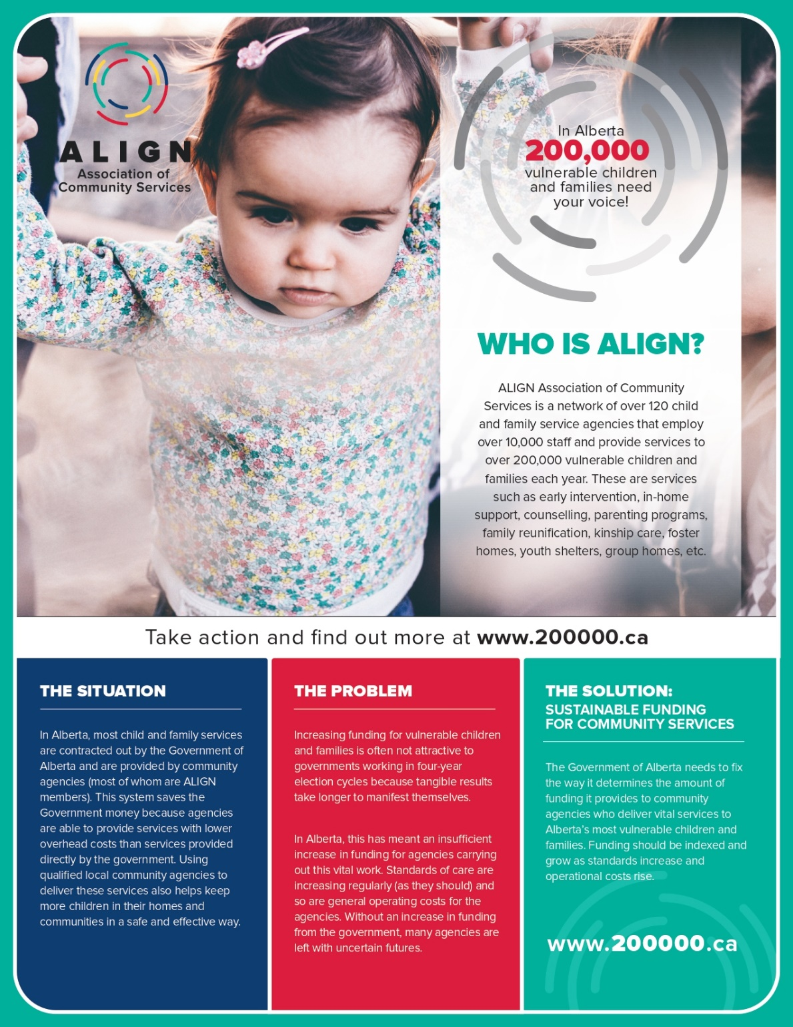

Glossary

Alberta Green Party (Greens)
Far left leaning political party with a particular focus on the environment.
Alberta Liberal Party (Liberal)
Left leaning political party with no current seats in the Legislature.
Alberta Party (ABP)
Relatively new party with limited success in previous elections. Centrist on the political spectrum.
Ballot
A piece of paper on which are printed the names of the candidates, their political parties and a place for the voter to indicate the preferred candidate.
Constituency Association
An organization endorsed by a registered party or an independent member of the Legislative Assembly to handle ongoing activities, including fundraising.
Door Knocking
Activity whereby a candidate, or their volunteers, go door-to-door to solicit support and votes
Election Day
The day or days fixed for voting at an election.
Electoral District
One of 87 areas in the province in which a slate of candidates contests a provincial election, and for which a Returning Officer (RO) is appointed and a Member of the Legislative Assembly is elected. Each is assigned a number in the Electoral Divisions Act.
Election Period
The 28-day period following the issuance of the Writs of Election and ending on Election Day.
GOTV (Get Out The Vote)
Organized efforts by a political party or campaign to encourage people to vote in an election with the effect of increasing the number of the campaign's supporters who will vote in the immediately approaching election.

New Democratic Party (NDP)
Currently the loyal opposition with democratic socialist beliefs. Left wing on the political spectrum
Nominated Candidate
A person who is nominated as a candidate for an electoral division, who is nominated by a constituency association of a registered party in an electoral division for endorsement as the official candidate of that party in the electoral division, or who, on or after the date of the issue of a writ for an election in an electoral division, declares the person’s candidacy as an independent candidate at the election in the electoral division
Platform (Party Platform)
A collection of beliefs, legislative goals, morals, and ideals. A political party's platform outlines their principles and plans to govern
Polling Place
A location (school, community league, etc.) where one or more polling stations are established for the purpose of voting at an election.
Polling Station
A station provided for electors in one polling subdivision to vote at an election. There may be several polling stations in one polling place.
Polling Subdivisions (PSD)
The units into which electoral divisions are divided for the purpose of effective election administration. There is a polling station established for each polling subdivision, at which a deputy returning officer and poll clerk manage the voting process. Several polling stations may exist in one polling place. Following polling day, all statistical information (voter turnout, percentage of popular vote, etc.) is compiled by polling subdivisions. By legislation, polling subdivisions are limited to 450 electors on average.
United Conservative Party (UCP)
Right wing political party formed through the amalgamation of the Progressive Conservatives and the Wildrose. Current party holding the most seats in the Legislature, forming Government.
Wildrose Independence Party (WIP)
Far right wing party formed to oppose the federal government and policies that harm Alberta. Nominally a separatist party.

