PRIDE Orientation Preservice Training Presentation
As promised, here is the link to download the PRIDE Orientation Preservice Training presentation files for uploading on your Website.
To begin please locate the link in your email. Download the file to your computer following the steps below:
- Click on the “Single-Click URL”. This will open a window as illustrated below.
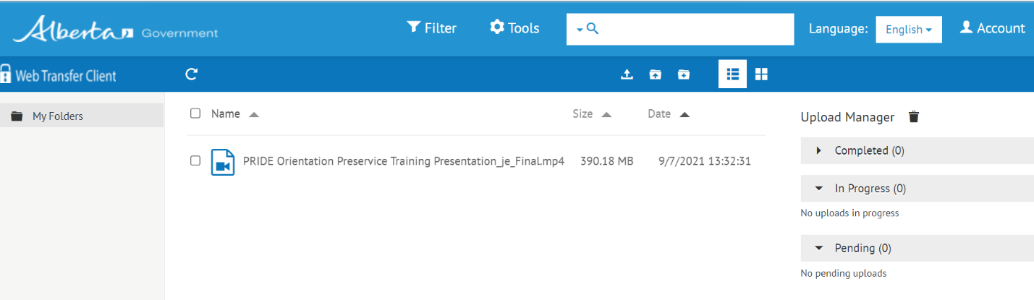

- The next step is to check off the box found near the left of the file and you will see download options at the top of the taskbar as shown below:
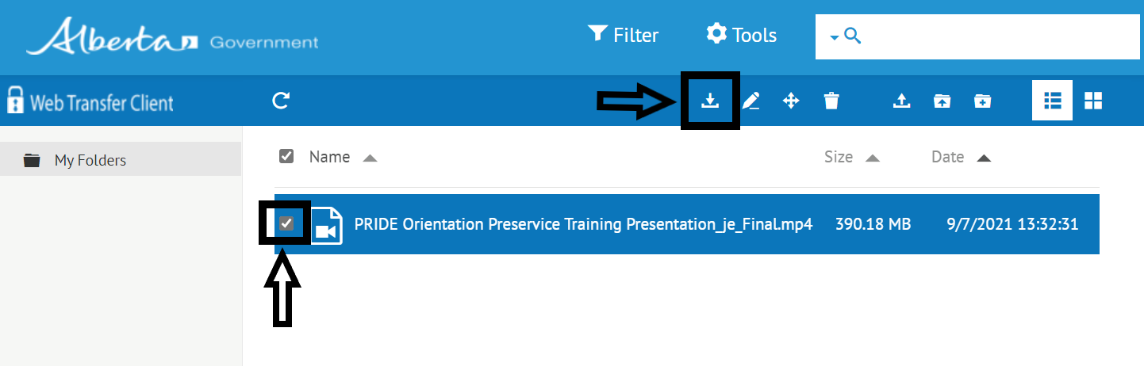

- Click on the download arrow at the top taskbar and the file will start downloading as illustrated below:
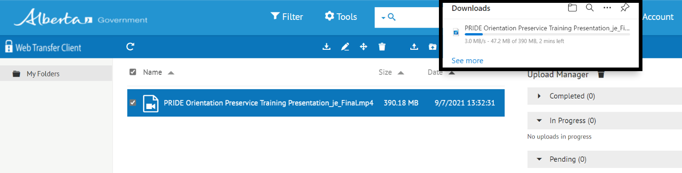

- Check your download folder and play the video from there.

Reminder. Please note that you should use a computer to open the link and not a smart phone or tablet. Remember that the link for the presentation will be valid for only one week due to GOA security protocols.

We thank you for providing this link on your ALIGN Webpage. It is our hope that these presentations will inform and inspire you in the work you provide across this province.

Should you have questions related to the presentations, please email us at CS.WFD@gov.ab.ca One of our staff will be happy to support your efforts.

All the best.

John Ewing
Sr. Learning & Development Consultant
Workforce Development
Transition and Intervention Supports Division
Children Services
Oxbridge Place, 5th Floor, 9820 – 106 Street
Edmonton, AB T2K 2J6

